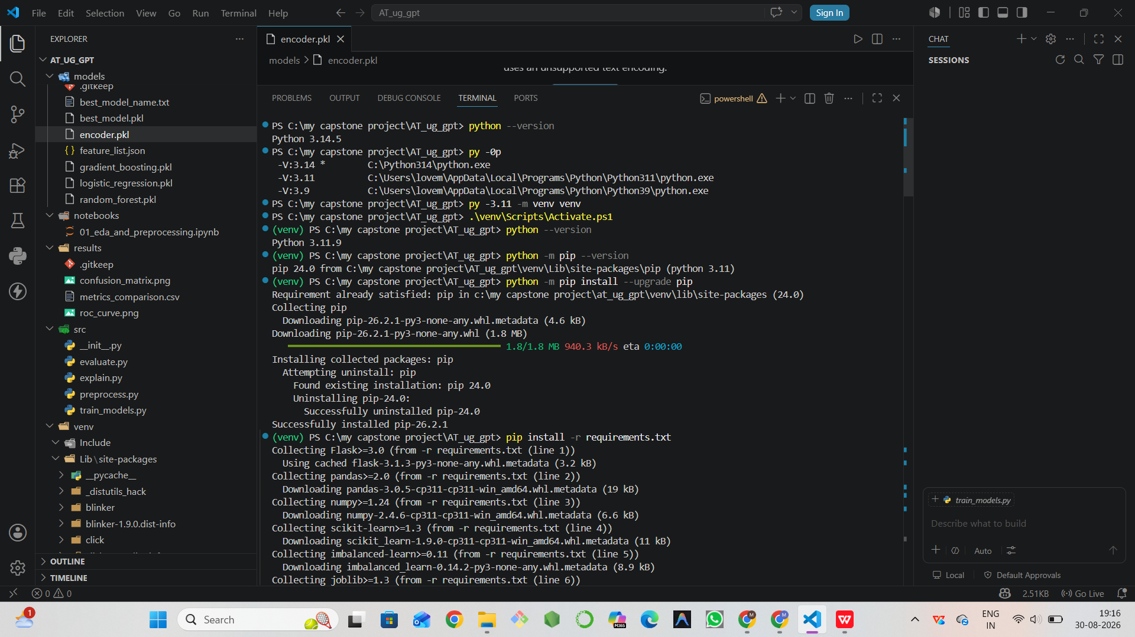

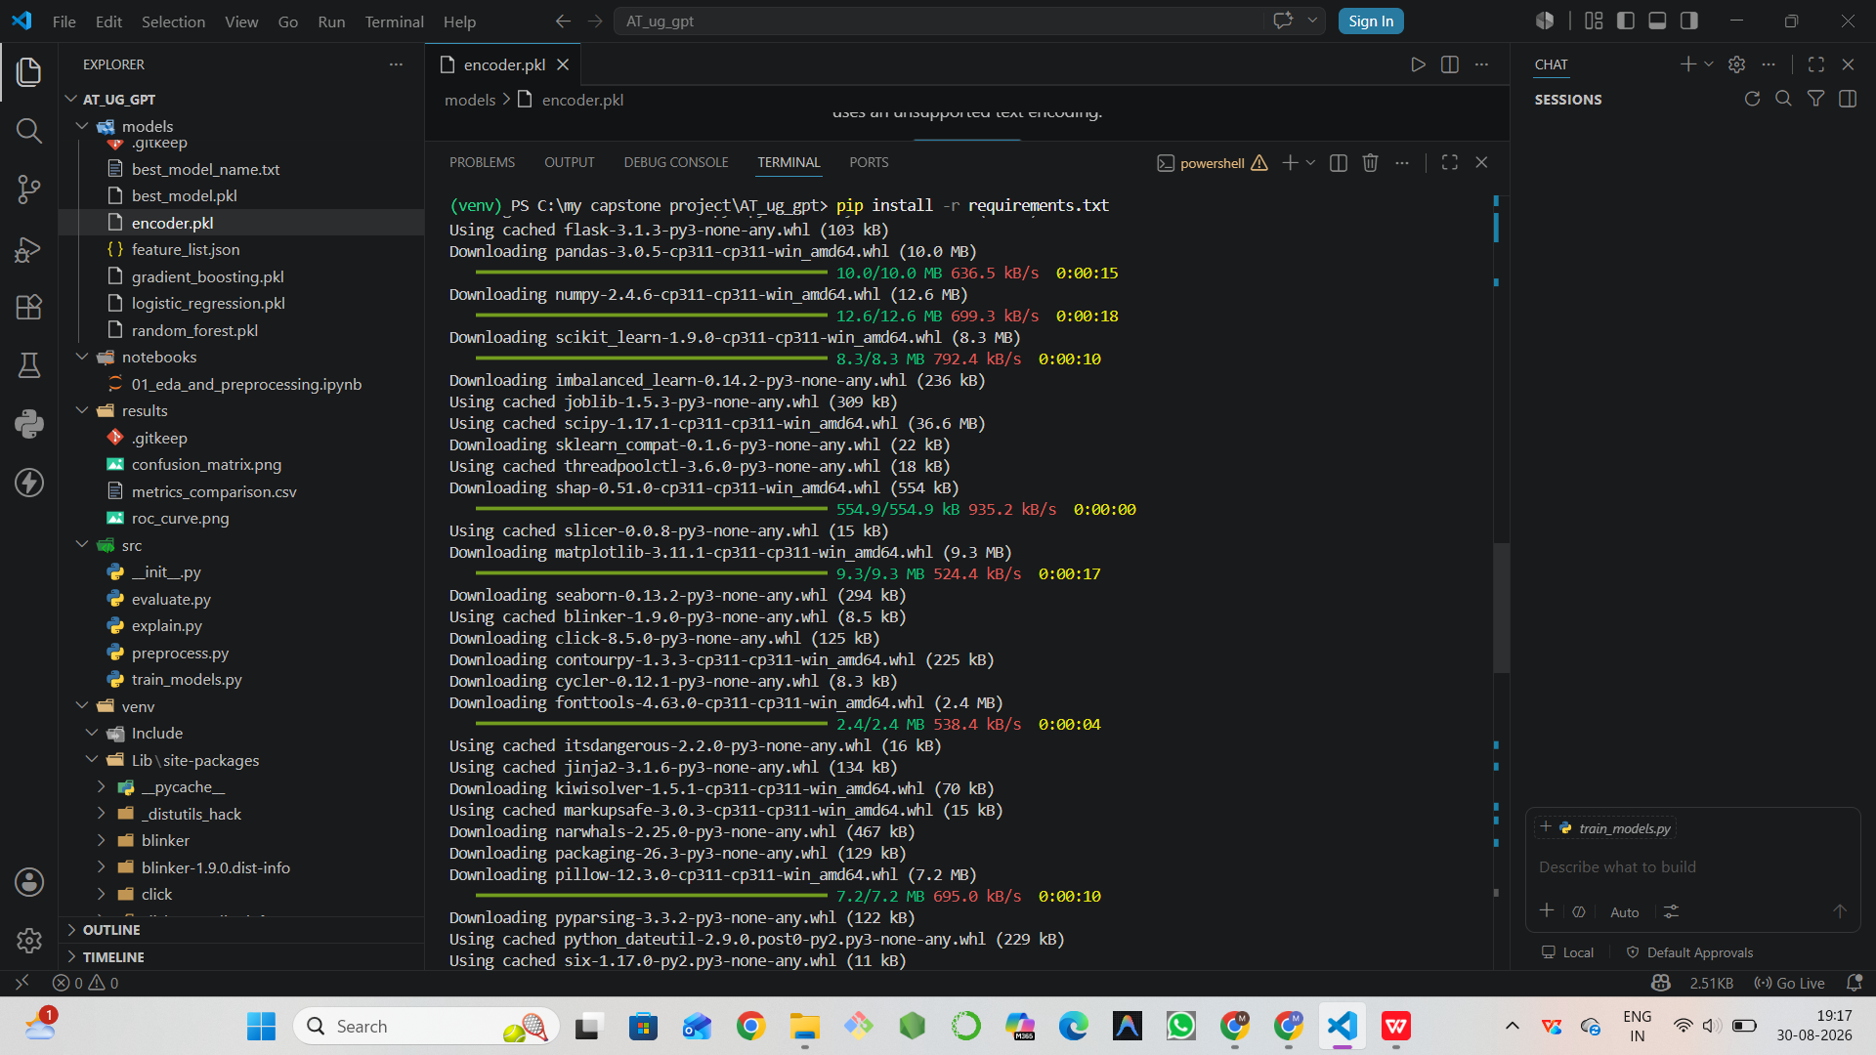

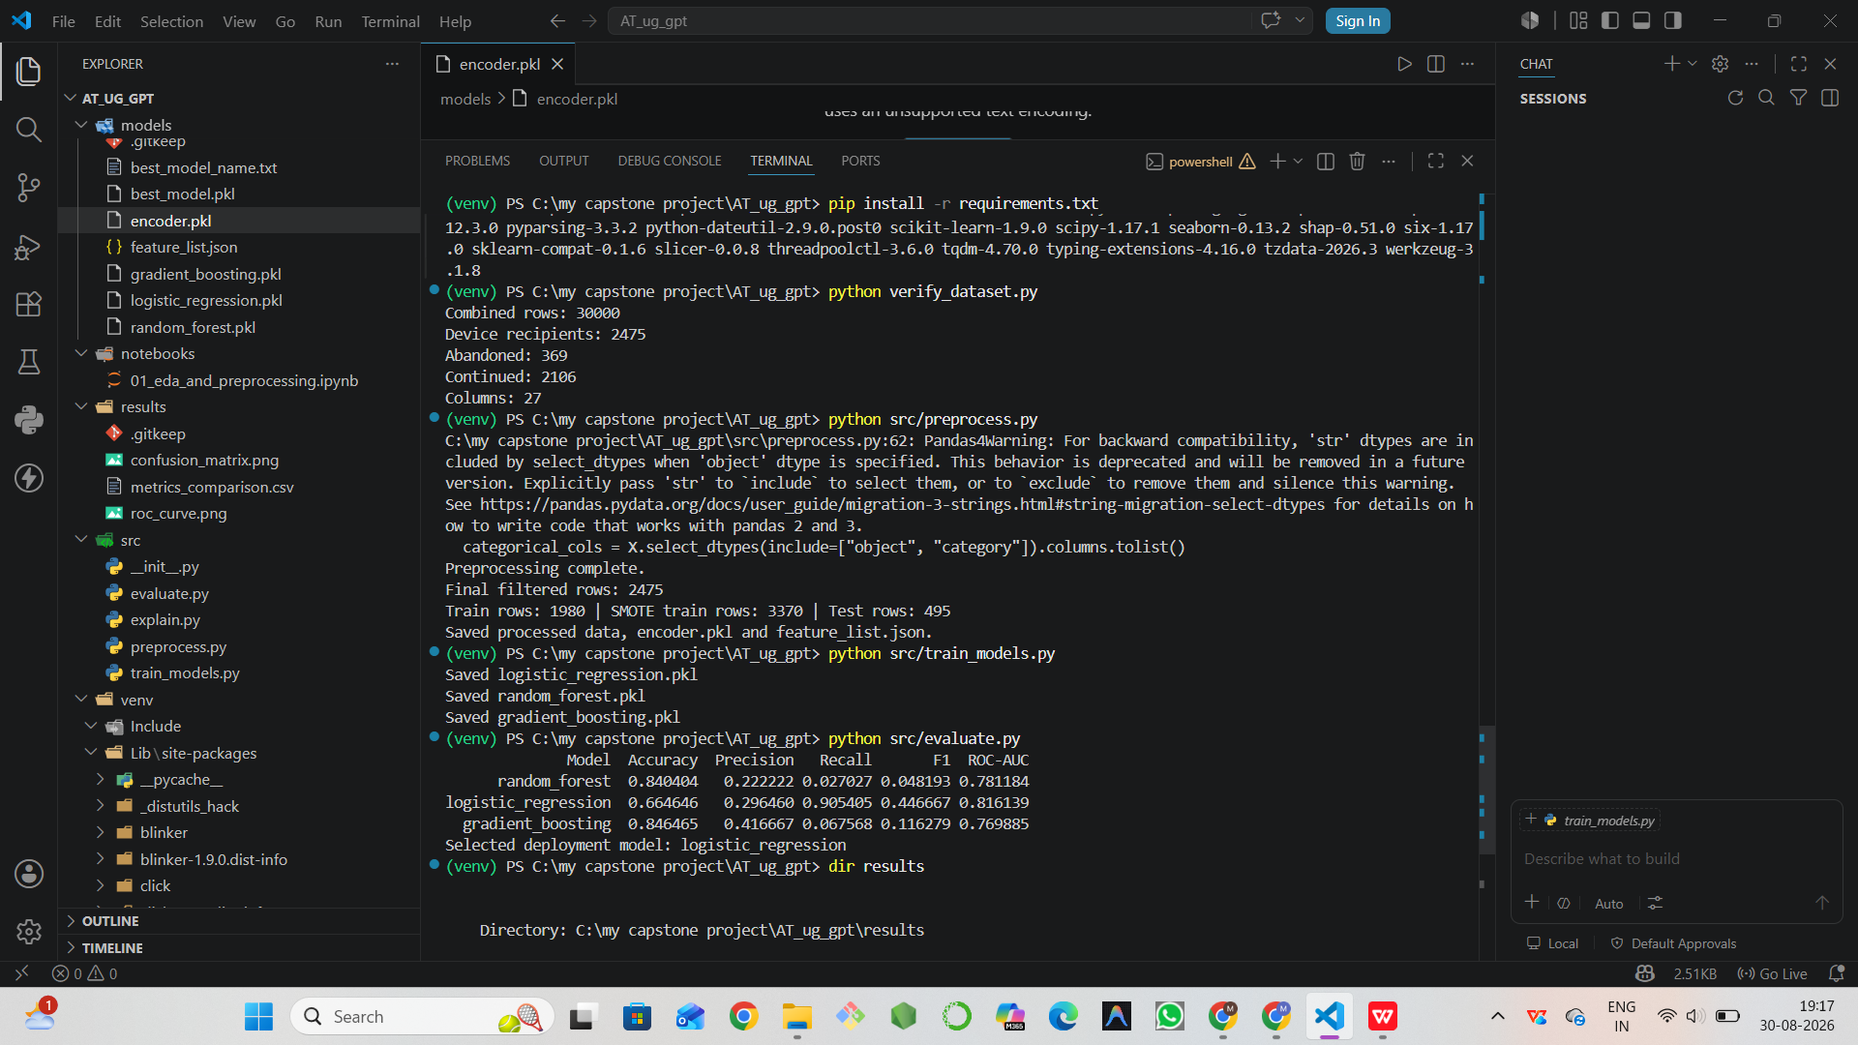

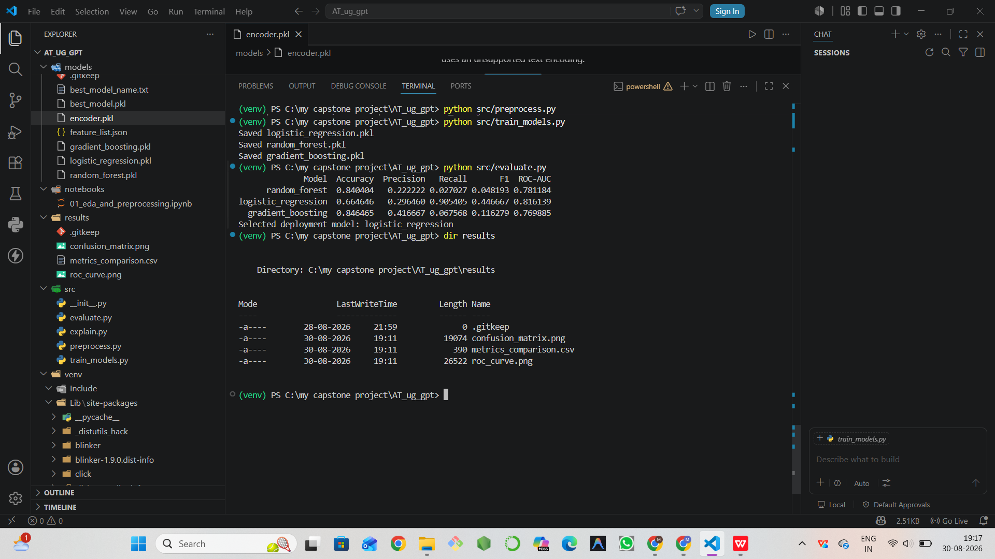

PS C:\my capstone project\AT_ug_gpt> python --version
Python 3.14.5
PS C:\my capstone project\AT_ug_gpt> py -0p
-V:3.14 * C:\Python314\python.exe
-V:3.11 C:\Users\lovem\AppData\Local\Programs\Python\Python311\python.exe
-V:3.9 C:\Users\lovem\AppData\Local\Programs\Python\Python39\python.exe
PS C:\my capstone project\AT_ug_gpt> py -3.11 -m venv venv
PS C:\my capstone project\AT_ug_gpt> .\venv\Scripts\Activate.ps1
(venv) PS C:\my capstone project\AT_ug_gpt> python --version
Python 3.11.9
(venv) PS C:\my capstone project\AT_ug_gpt> python -m pip --version
pip 24.0 from C:\my capstone project\AT_ug_gpt\venv\Lib\site-packages\pip (python 3.11)
(venv) PS C:\my capstone project\AT_ug_gpt> python -m pip install --upgrade pip
Requirement already satisfied: pip in c:\my capstone project\at_ug_gpt\venv\lib\site-packages (24.0)
Collecting pip
Downloading pip-26.2.1-py3-none-any.whl.metadata (4.6 kB)
Downloading pip-26.2.1-py3-none-any.whl (1.8 MB)
━━━━━━━━━━━━━━━━━━━━━━━━━━━━━━━━━━━━━━━━ 1.8/1.8 MB 940.3 kB/s eta 0:00:00
Installing collected packages: pip
Attempting uninstall: pip
Found existing installation: pip 24.0
Uninstalling pip-24.0:
Successfully uninstalled pip-24.0
Successfully installed pip-26.2.1
(venv) PS C:\my capstone project\AT_ug_gpt> pip install -r requirements.txt
Collecting Flask>=3.0 (from -r requirements.txt (line 1))
Using cached flask-3.1.3-py3-none-any.whl.metadata (3.2 kB)
Collecting pandas>=2.0 (from -r requirements.txt (line 2))
Downloading pandas-3.0.5-cp311-cp311-win_amd64.whl.metadata (19 kB)
Collecting numpy>=1.24 (from -r requirements.txt (line 3))
Downloading numpy-2.4.6-cp311-cp311-win_amd64.whl.metadata (6.6 kB)
Collecting scikit-learn>=1.3 (from -r requirements.txt (line 4))
Downloading scikit_learn-1.9.0-cp311-cp311-win_amd64.whl.metadata (11 kB)
Collecting imbalanced-learn>=0.11 (from -r requirements.txt (line 5))
Downloading imbalanced_learn-0.14.2-py3-none-any.whl.metadata (8.9 kB)
Collecting joblib>=1.3 (from -r requirements.txt (line 6))
Using cached joblib-1.5.3-py3-none-any.whl.metadata (5.5 kB)
Collecting shap>=0.45 (from -r requirements.txt (line 7))
Downloading shap-0.51.0-cp311-cp311-win_amd64.whl.metadata (26 kB)
Collecting matplotlib>=3.7 (from -r requirements.txt (line 8))
Downloading matplotlib-3.11.1-cp311-cp311-win_amd64.whl.metadata (80 kB)
Collecting seaborn>=0.13 (from -r requirements.txt (line 9))
Downloading seaborn-0.13.2-py3-none-any.whl.metadata (5.4 kB)
Collecting blinker>=1.9.0 (from Flask>=3.0->-r requirements.txt (line 1))
Using cached blinker-1.9.0-py3-none-any.whl.metadata (1.6 kB)
Collecting click>=8.1.3 (from Flask>=3.0->-r requirements.txt (line 1))
Downloading click-8.5.0-py3-none-any.whl.metadata (2.6 kB)
Collecting itsdangerous>=2.2.0 (from Flask>=3.0->-r requirements.txt (line 1))
Using cached itsdangerous-2.2.0-py3-none-any.whl.metadata (1.9 kB)
Collecting jinja2>=3.1.2 (from Flask>=3.0->-r requirements.txt (line 1))
Using cached jinja2-3.1.6-py3-none-any.whl.metadata (2.9 kB)
Collecting markupsafe>=2.1.1 (from Flask>=3.0->-r requirements.txt (line 1))
Using cached markupsafe-3.0.3-cp311-cp311-win_amd64.whl.metadata (2.8 kB)
Collecting werkzeug>=3.1.0 (from Flask>=3.0->-r requirements.txt (line 1))
Using cached werkzeug-3.1.8-py3-none-any.whl.metadata (4.0 kB)
Collecting python-dateutil>=2.8.2 (from pandas>=2.0->-r requirements.txt (line 2))
Using cached python_dateutil-2.9.0.post0-py2.py3-none-any.whl.metadata (8.4 kB)
Collecting tzdata (from pandas>=2.0->-r requirements.txt (line 2))
Using cached tzdata-2026.3-py2.py3-none-any.whl.metadata (1.4 kB)
Collecting scipy>=1.10.0 (from scikit-learn>=1.3->-r requirements.txt (line 4))
Using cached scipy-1.17.1-cp311-cp311-win_amd64.whl.metadata (60 kB)
Collecting narwhals>=2.0.1 (from scikit-learn>=1.3->-r requirements.txt (line 4))
Downloading narwhals-2.25.0-py3-none-any.whl.metadata (15 kB)
Collecting threadpoolctl>=3.5.0 (from scikit-learn>=1.3->-r requirements.txt (line 4))
Using cached threadpoolctl-3.6.0-py3-none-any.whl.metadata (13 kB)
Collecting sklearn-compat<0.2,>=0.1.6 (from imbalanced-learn>=0.11->-r requirements.txt (line 5))
Downloading sklearn_compat-0.1.6-py3-none-any.whl.metadata (22 kB)
Collecting tqdm>=4.27.0 (from shap>=0.45->-r requirements.txt (line 7))
Using cached tqdm-4.70.0-py3-none-any.whl.metadata (57 kB)
Collecting packaging>20.9 (from shap>=0.45->-r requirements.txt (line 7))
Downloading packaging-26.3-py3-none-any.whl.metadata (3.5 kB)
Collecting slicer==0.0.8 (from shap>=0.45->-r requirements.txt (line 7))
Using cached slicer-0.0.8-py3-none-any.whl.metadata (4.0 kB)
Collecting numba (from shap>=0.45->-r requirements.txt (line 7))
Downloading numba-0.67.0-cp311-cp311-win_amd64.whl.metadata (2.8 kB)
Collecting llvmlite (from shap>=0.45->-r requirements.txt (line 7))
Downloading llvmlite-0.49.0-cp311-cp311-win_amd64.whl.metadata (4.9 kB)
Collecting cloudpickle (from shap>=0.45->-r requirements.txt (line 7))
Using cached cloudpickle-3.1.2-py3-none-any.whl.metadata (7.1 kB)
Collecting typing-extensions (from shap>=0.45->-r requirements.txt (line 7))
Using cached typing_extensions-4.16.0-py3-none-any.whl.metadata (3.3 kB)
Collecting contourpy>=1.0.1 (from matplotlib>=3.7->-r requirements.txt (line 8))
Downloading contourpy-1.3.3-cp311-cp311-win_amd64.whl.metadata (5.5 kB)
Collecting cycler>=0.10 (from matplotlib>=3.7->-r requirements.txt (line 8))
Downloading cycler-0.12.1-py3-none-any.whl.metadata (3.8 kB)
Collecting fonttools>=4.28.2 (from matplotlib>=3.7->-r requirements.txt (line 8))
Downloading fonttools-4.63.0-cp311-cp311-win_amd64.whl.metadata (121 kB)
Collecting kiwisolver>=1.3.1 (from matplotlib>=3.7->-r requirements.txt (line 8))
Downloading kiwisolver-1.5.1-cp311-cp311-win_amd64.whl.metadata (5.2 kB)
Collecting pillow>=9 (from matplotlib>=3.7->-r requirements.txt (line 8))
Downloading pillow-12.3.0-cp311-cp311-win_amd64.whl.metadata (9.3 kB)
Collecting pyparsing>=3 (from matplotlib>=3.7->-r requirements.txt (line 8))
Downloading pyparsing-3.3.2-py3-none-any.whl.metadata (5.8 kB)
Collecting six>=1.5 (from python-dateutil>=2.8.2->pandas>=2.0->-r requirements.txt (line 2))
Using cached six-1.17.0-py2.py3-none-any.whl.metadata (1.7 kB)
Collecting colorama (from tqdm>=4.27.0->shap>=0.45->-r requirements.txt (line 7))
Using cached colorama-0.4.6-py2.py3-none-any.whl.metadata (17 kB)
Using cached flask-3.1.3-py3-none-any.whl (103 kB)
Downloading pandas-3.0.5-cp311-cp311-win_amd64.whl (10.0 MB)
━━━━━━━━━━━━━━━━━━━━━━━━━━━━━━━━━━━━━━━━ 10.0/10.0 MB 636.5 kB/s 0:00:15
Downloading numpy-2.4.6-cp311-cp311-win_amd64.whl (12.6 MB)
━━━━━━━━━━━━━━━━━━━━━━━━━━━━━━━━━━━━━━━━ 12.6/12.6 MB 699.3 kB/s 0:00:18
Downloading scikit_learn-1.9.0-cp311-cp311-win_amd64.whl (8.3 MB)
━━━━━━━━━━━━━━━━━━━━━━━━━━━━━━━━━━━━━━━━ 8.3/8.3 MB 792.4 kB/s 0:00:10
Downloading imbalanced_learn-0.14.2-py3-none-any.whl (236 kB)
Using cached joblib-1.5.3-py3-none-any.whl (309 kB)
Using cached scipy-1.17.1-cp311-cp311-win_amd64.whl (36.6 MB)
Downloading sklearn_compat-0.1.6-py3-none-any.whl (22 kB)
Using cached threadpoolctl-3.6.0-py3-none-any.whl (18 kB)
Downloading shap-0.51.0-cp311-cp311-win_amd64.whl (554 kB)
━━━━━━━━━━━━━━━━━━━━━━━━━━━━━━━━━━━━━━━━ 554.9/554.9 kB 935.2 kB/s 0:00:00
Using cached slicer-0.0.8-py3-none-any.whl (15 kB)
Downloading matplotlib-3.11.1-cp311-cp311-win_amd64.whl (9.3 MB)
━━━━━━━━━━━━━━━━━━━━━━━━━━━━━━━━━━━━━━━━ 9.3/9.3 MB 524.4 kB/s 0:00:17
Downloading seaborn-0.13.2-py3-none-any.whl (294 kB)
Using cached blinker-1.9.0-py3-none-any.whl (8.5 kB)
Downloading click-8.5.0-py3-none-any.whl (125 kB)
Downloading contourpy-1.3.3-cp311-cp311-win_amd64.whl (225 kB)
Downloading cycler-0.12.1-py3-none-any.whl (8.3 kB)
Downloading fonttools-4.63.0-cp311-cp311-win_amd64.whl (2.4 MB)
━━━━━━━━━━━━━━━━━━━━━━━━━━━━━━━━━━━━━━━━ 2.4/2.4 MB 538.4 kB/s 0:00:04
Using cached itsdangerous-2.2.0-py3-none-any.whl (16 kB)
Using cached jinja2-3.1.6-py3-none-any.whl (134 kB)
Downloading kiwisolver-1.5.1-cp311-cp311-win_amd64.whl (70 kB)
Using cached markupsafe-3.0.3-cp311-cp311-win_amd64.whl (15 kB)
Downloading narwhals-2.25.0-py3-none-any.whl (467 kB)
Downloading packaging-26.3-py3-none-any.whl (129 kB)
Downloading pillow-12.3.0-cp311-cp311-win_amd64.whl (7.2 MB)
━━━━━━━━━━━━━━━━━━━━━━━━━━━━━━━━━━━━━━━━ 7.2/7.2 MB 695.0 kB/s 0:00:10
Downloading pyparsing-3.3.2-py3-none-any.whl (122 kB)
Using cached python_dateutil-2.9.0.post0-py2.py3-none-any.whl (229 kB)
Using cached six-1.17.0-py2.py3-none-any.whl (11 kB)
Using cached tqdm-4.70.0-py3-none-any.whl (80 kB)
Using cached werkzeug-3.1.8-py3-none-any.whl (226 kB)
Using cached cloudpickle-3.1.2-py3-none-any.whl (22 kB)
Using cached colorama-0.4.6-py2.py3-none-any.whl (25 kB)
Downloading llvmlite-0.49.0-cp311-cp311-win_amd64.whl (41.9 MB)
━━━━━━━━━━━━━━━━━━━━━━━━━━━━━━━━━━━━━━━━ 41.9/41.9 MB 765.2 kB/s 0:00:52
Downloading numba-0.67.0-cp311-cp311-win_amd64.whl (2.8 MB)
━━━━━━━━━━━━━━━━━━━━━━━━━━━━━━━━━━━━━━━━ 2.8/2.8 MB 454.0 kB/s 0:00:06
Using cached typing_extensions-4.16.0-py3-none-any.whl (45 kB)
Using cached tzdata-2026.3-py2.py3-none-any.whl (348 kB)
Installing collected packages: tzdata, typing-extensions, threadpoolctl, slicer, six, pyparsing, pillow, packaging, numpy, narwhals, markupsafe, llvmlite, kiwisolver, joblib, itsdangerous, fonttools, cycler, colorama, cloudpickle, click, blinker, werkzeug, tqdm, scipy, python-dateutil, numba, jinja2, contourpy, scikit-learn, pandas, matplotlib, Flask, sklearn-compat, shap, seaborn, imbalanced-learn
Successfully installed Flask-3.1.3 blinker-1.9.0 click-8.5.0 cloudpickle-3.1.2 colorama-0.4.6 contourpy-1.3.3 cycler-0.12.1 fonttools-4.63.0 imbalanced-learn-0.14.2 itsdangerous-2.2.0 jinja2-3.1.6 joblib-1.5.3 kiwisolver-1.5.1 llvmlite-0.49.0 markupsafe-3.0.3 matplotlib-3.11.1 narwhals-2.25.0 numba-0.67.0 numpy-2.4.6 packaging-26.3 pandas-3.0.5 pillow-12.3.0 pyparsing-3.3.2 python-dateutil-2.9.0.post0 scikit-learn-1.9.0 scipy-1.17.1 seaborn-0.13.2 shap-0.51.0 six-1.17.0 sklearn-compat-0.1.6 slicer-0.0.8 threadpoolctl-3.6.0 tqdm-4.70.0 typing-extensions-4.16.0 tzdata-2026.3 werkzeug-3.1.8
(venv) PS C:\my capstone project\AT_ug_gpt> python verify_dataset.py
Combined rows: 30000
Device recipients: 2475
Abandoned: 369
Continued: 2106
Columns: 27
(venv) PS C:\my capstone project\AT_ug_gpt> python src/preprocess.py
C:\my capstone project\AT_ug_gpt\src\preprocess.py:62: Pandas4Warning: For backward compatibility, 'str' dtypes are included by select_dtypes when 'object' dtype is specified. This behavior is deprecated and will be removed in a future version. Explicitly pass 'str' to `include` to select them, or to `exclude` to remove them and silence this warning.
See https://pandas.pydata.org/docs/user_guide/migration-3-strings.html#string-migration-select-dtypes for details on how to write code that works with pandas 2 and 3.
categorical_cols = X.select_dtypes(include=["object", "category"]).columns.tolist()
Preprocessing complete.
Final filtered rows: 2475
Train rows: 1980 | SMOTE train rows: 3370 | Test rows: 495
Saved processed data, encoder.pkl and feature_list.json.
(venv) PS C:\my capstone project\AT_ug_gpt> python src/train_models.py
Saved logistic_regression.pkl
Saved random_forest.pkl
Saved gradient_boosting.pkl
(venv) PS C:\my capstone project\AT_ug_gpt> python src/evaluate.py
Model Accuracy Precision Recall F1 ROC-AUC
random_forest 0.840404 0.222222 0.027027 0.048193 0.781184
logistic_regression 0.664646 0.296460 0.905405 0.446667 0.816139
gradient_boosting 0.846465 0.416667 0.067568 0.116279 0.769885
Selected deployment model: logistic_regression
(venv) PS C:\my capstone project\AT_ug_gpt> dir results

Directory: C:\my capstone project\AT_ug_gpt\results

Mode LastWriteTime Length Name
---- ------------- ------ ----
-a---- 28-08-2026 21:59 0 .gitkeep
-a---- 30-08-2026 19:11 19074 confusion_matrix.png
-a---- 30-08-2026 19:11 390 metrics_comparison.csv
-a---- 30-08-2026 19:11 26522 roc_curve.png

(venv) PS C:\my capstone project\AT_ug_gpt>

